June 2020
User manual v1.0
Containment Basic ™
General Overview
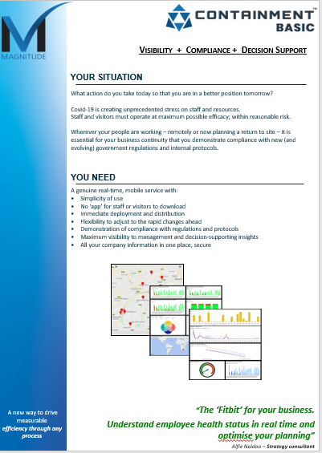
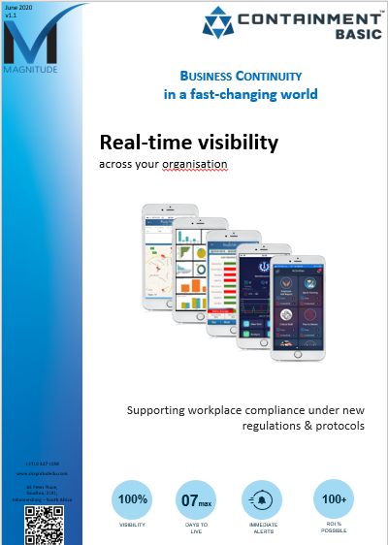
- Brochure

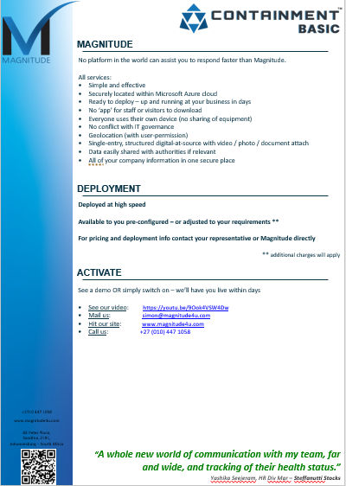
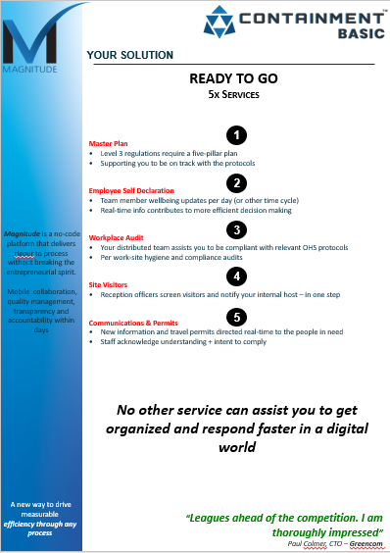

- Service Objective
  - Containment Basic ™ is a simple tool designed to assist your organisation to do the routine work necessary under the rapidly evolving SA regulations for management of workspaces; intended to minimise risk of Covid-19 infections.
  - This manual provides you with the minimum necessary knowledge to use the tool effectively.
- Key Users
  - Containment Basic ™ has been designed on the basis that a minimum of only 2 people need to be authenticated on the service. All other users engage with the service with no need to download software, nor to login into the system.
  - The minimum 2 authenticated users who will login into the mobile app or the web app are:
    - Compliance officer [primary user]
    - Reception officer, for visitors [secondary user]

Service Processes

There are 5 x processes within the service known as Activities. These are:
- Master Plan
- Communications & Permits
- Employee Declaration
- Workplace Audits
- Site Visitor

These activities support your organisation to meet the necessary compliance protocols within the Level-3 regulations as referenced at: https://www.return2work.co.za/

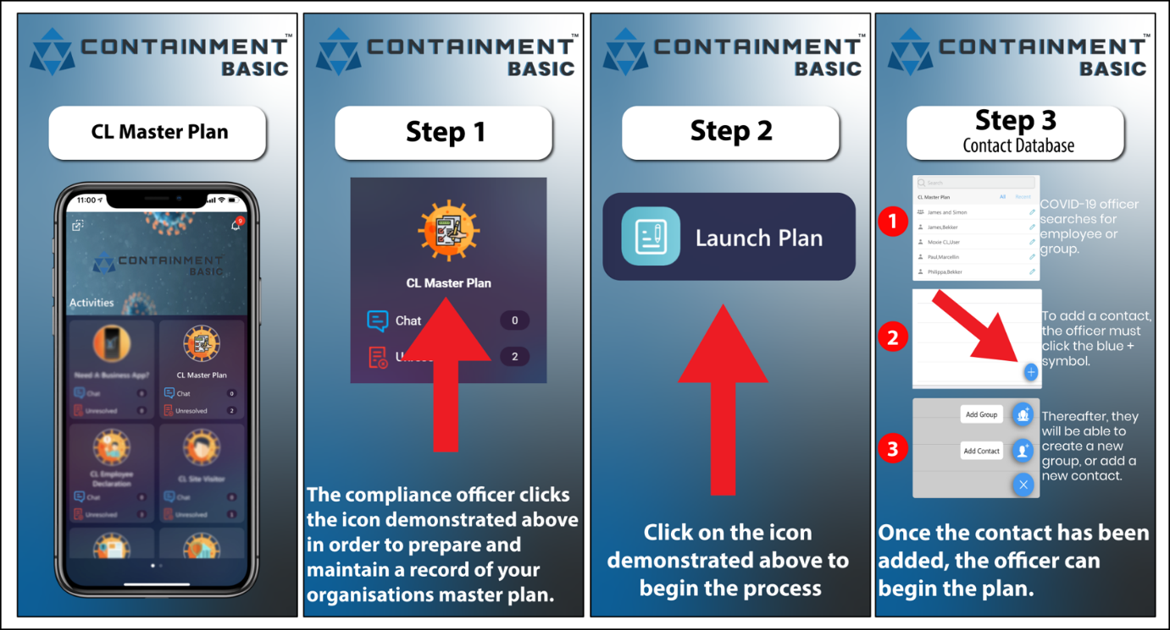
- Master Plan
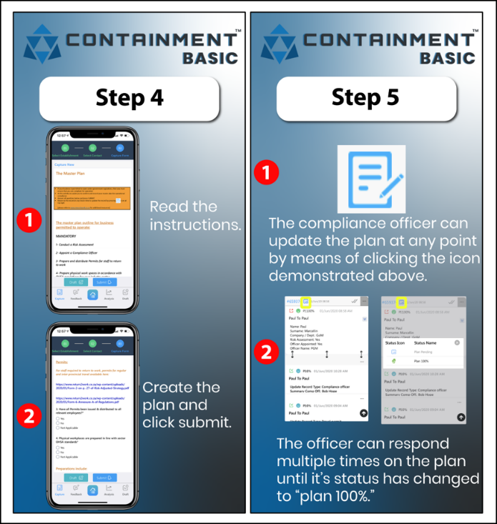

This activity allows you to prepare and maintain a record of your organisation’s master plan to be compliant with government regulations / protocols regarding people safety.

To assist you in this process, we have sourced information at: www.return2work.co.za

The activity is controlled by your compliance officer / H&S officer.
The compliance officer will have a login access to the Containment app / web-app.

The compliance officer will complete the digital form per relevant site. Attachments can be included, as required.
At any time they are able to update the information.

All information and attachments and updates are permanently recorded by site.

Each active record (plan) should be left UNRESOLVED in the system – this indicates to the compliance officer which plan/s are active.

Process flow:

Part A
This part of the process is done once per site / BU / organisation / other
- Select activity: Master Plan
- Select Launch Plan
- Select yourself in the contact data base, and select SUBMIT
- Complete the digital form
- Select SUBMIT
Part B
This part of the process is done IF you have updated information for the site / BU / organisation / other
- Select activity: Master Plan
- Select All Records
- Find and select the relevant record (can use filter buttons, if necessary)
- Select the blue icon [blue clipboard] on the top right side of the record
- Complete the digital form
- Select SUBMIT
- Note:
this part B action can be repeated as often as necessary with any further updates
- The Unresolved indicator on the Master Plan tile will inform you as to how many unique plans you have open (‘alive’) across your organisation, within your user rights
Notifications:
- Notifications are not relevant in this process
Plan records:
- All planning information and updates are on permanent record
Resolve function:
- The resolve function closes out a record, so that it is no longer highlighted for attention; but it always remains accessible
- This process is designed to keep records non-resolved until the compliance officer no longer requires the plan to be active
- To resolve a record, tap on the ‘tick’ icon on the records page
- It is possible to un-resolve any record by repeating this action
- The system logs the name of the user and date-stamps with every resolve / un-resolve

Context-relevant chat messages:
- Below every record there is a blue action chat bar
- To discuss an issue with a specific team member(s), all internal colleagues
- Select the chat bar
- Enter the @ sign
- From the drop down list, select one or more colleagues
- Colleagues who are external to the app will have an email address and/or mobile number
- When you have selected the colleague(s), type your message
- Press the + sign in order to access:
  - Attachment clip
  - Geo-location pin
  - Quick template (preloaded messages)
  - Calendar reminder
- Note:
- You can make a general note by selecting @Me as the target
- It is NOT possible to delete a chat record – be careful
- All internal colleagues (with a login access) can see all chats, whether it is @them or not
Analysis:
- Select activity: Master Plan
- Select Analysis
- Select any one of the options to view summary data from various points of view
Download:
On the web app / browser interface only you have the option to download your info in a PDF or Excel / CSV format
- Select activity: Master Plan
- Select All Records
- Click on the date-range and engage filters / dates / etc to narrow your records selection
  - Select the EXCEL icon at top right
or
  - Click on a specific record
  - Click on the 3 x dots button
  - Select Export PDF

- Communications & Permits
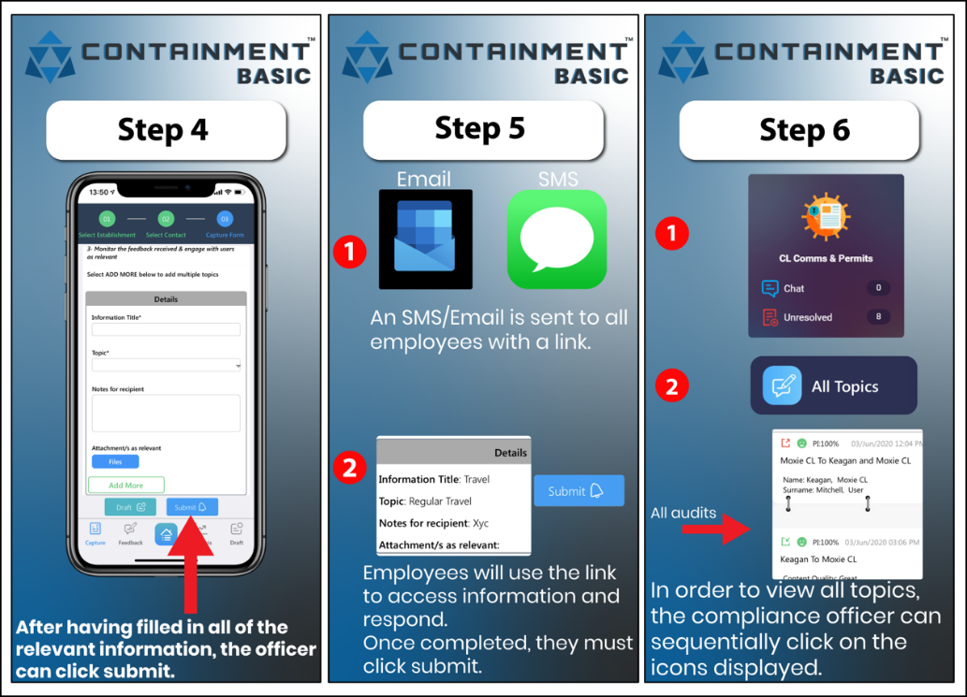
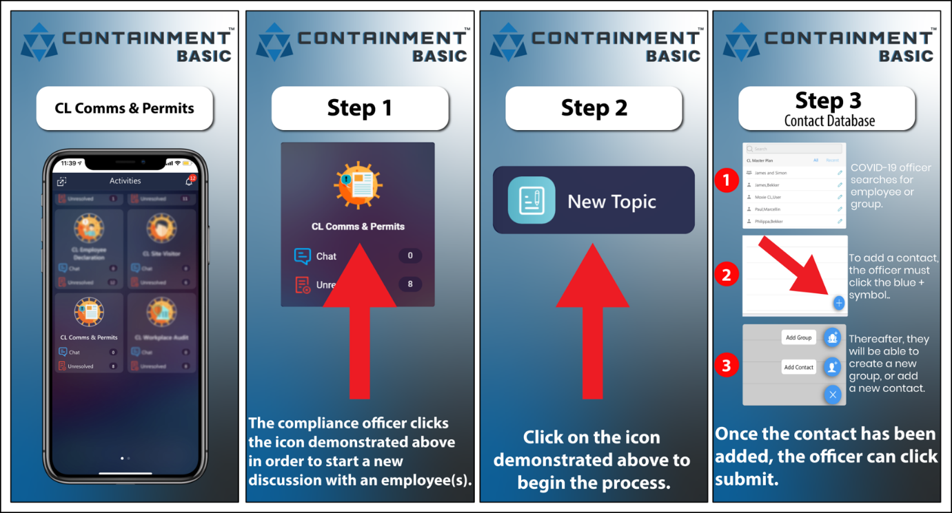

This activity allows you to distribute information and travel permits to any specific team member or group.

The activity is controlled by your compliance officer / H&S officer.
It is a one-to-one or a one-to-many service.

Your compliance officer will have a login access to the Containment app / web-app, but the rest of your staff who receive this information have no need for an app. Only a smart / feature phone or laptop with an internet connection is required.

The information will be received by relevant team members. They will be able to acknowledge their understanding and compliance of the information received. All communications will be saved to your records and linked to the named team member (username protected).
Both parties are able to include documents / photos / videos and links to videos in the communications.

Process flow:
- Select activity: Comms + Permits
- Select New Topic
- Select the team member who will be assisting you at that site, OR add the employee [head+ icon]
- If relevant select a Group of team members, OR create a group by clicking on the icon [multiple-head +]
  - Give your group a name
  - Select the icon [head] to search for and select new group members
  - Select Done
  - Select Submit and Ok
- Complete the digital form as relevant and select SUBMIT
- Note:
The Add More button enables you to layer up additional communications or permits with the person(s) that you are communicating with
Notifications:
- Will be received per team member response by all your personnel with the relevant access rights
- Notifications will be in-app
- If required, notifications can be de-activated at the Settings icon
Site records:
- Original communication and the response from each team member is stored with their name and topic, as well as date of submission
- Each response record has an indicative score, dependant on the answers given
Resolve function:
- The resolve function closes out a record, so that it is no longer highlighted for attention; but it always remains accessible
- This process is designed to have records resolved when the compliance officer is satisfied with the response of the parties receiving info / permits
- To resolve a record, tap on the ‘tick’ icon on the records page
- It is possible to un-resolve any record by repeating this action
- The system logs the name of the user and date-stamps each resolve / un-resolve
Context-relevant chat messages:
- Below every record there is a blue action chat bar
- To discuss an issue with a specific team member(s), all internal colleagues
- Select the chat bar
- Enter the @ sign
- From the drop list, select one or more colleagues
- Colleagues who are external to the app will have an email address and/or mobile number
- When you have selected colleague(s), type your message
- Press the + sign in order to access:
  - Attachment clip
  - Geo-location pin
  - Quick template (preloaded messages)
  - Calendar reminder

- Note:
- You can make a general note by selecting @Me as the target
- It is NOT possible to delete a chat record – be careful
- All internal colleagues (with a login access) can see all chats, whether it is @them or not
Analysis:
- Select activity: Comms + Permits
- Select button Analysis
- Select any one of the options to view summary data from various points of view
Download:
On the web app / browser interface only you have the option to download your info in a PDF or Excel / CSV format
- Select activity: Comms + Permits
- Select button Open Records
- Click on the date-range and engage filters / dates / etc to narrow your records selection
  - Select the EXCEL icon at top right
or
  - Click on a specific record
  - Click on the 3x dots button
  - Select Export PDF

- Employee Declaration
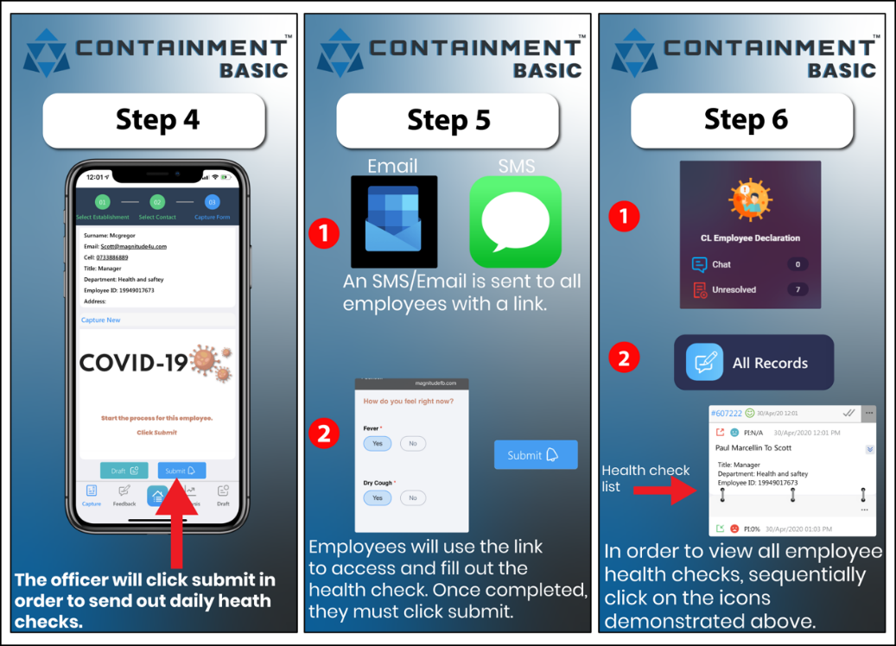
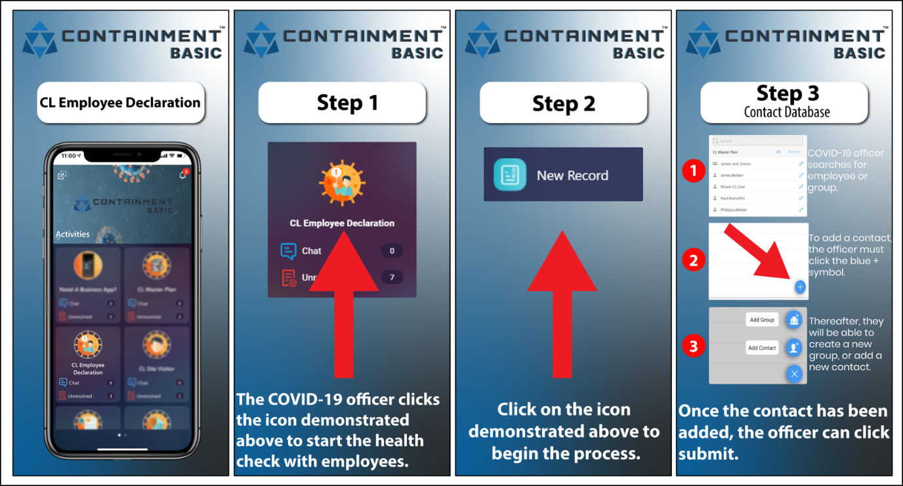

This activity allows your organisation to understand the wellbeing of each employee based on a fast self-assessment per time period (eg. per day).

The activity is controlled by your compliance officer / H&S officer.

Your compliance officer will have a login access to the Containment app / web-app, but the rest of your staff have no need for an app; only a smart / feature phone OR laptop with an internet connection.

The information submitted by employees will be permanently recorded (username protected) and will enable your organisation to quickly understand who is feeling less than 100%, in any given cycle.

Process flow:

Part A
This part of the process is done only once per employee
- Select activity: Employee Declaration
- Select the specific employee in the contact data base OR add the employee [head+ icon]
- Select SUBMIT
Part B
This part of the process is done per your organisation time-cycle – eg per day
- Access your browser-based web app (not your mobile app)
- At top right of screen select settings [gear icon]
- From drop-list select Resend Notification
- Find Employee Declaration
- Select Resend + Yes
- The reminder is sent by SMS and email across all records which remain unresolved – meaning they are ‘open’ and to be updated by your team members
Notifications:
- Will be received per employee submission by all your personnel with the relevant access rights
- Notifications will be in-app
- If required notifications can be de-activated at the Settings icon
Employee records:
- The response from each employee is stored against their name, per date of submission
- Each submitted record has an indicative score, dependant on how the employee answered across the question set
Resolve function:
- The resolve function closes out a record. It is no longer highlighted for attention; but it always remains accessible
- This process is designed to have records remain non-resolved until the compliance officer no longer requires to have a particular employee make a declaration, per time cycle
  - By leaving records non-resolved enables the compliance officer to see how many colleagues he/she is maintaining rolling declarations for
- To resolve a record, tap on the ‘tick’ icon on the records page
- It is possible to un-resolve any record by repeating this action
- The system logs the name of the user and date-stamps each resolve / un-resolve
Context-relevant chat messages:
- Below every record there is a blue action chat bar
- To discuss an issue with a specific team member(s), all internal colleagues
- Select the chat bar
- Enter the @ sign
- From the drop list select one or more colleagues
- Colleagues who are external to the app will have an email address and/or mobile number

- When you have selected colleague(s) type your message
- Press the + sign in order to access:
  - Attachment clip
  - Geo-location pin
  - Quick template (preloaded messages)
  - Calendar reminder
- Note:
- You can make a general note by selecting @Me as the target
- It is NOT possible to delete a chat record – be careful
- All internal colleagues (with a login access) can see all chats, whether it is @them or not
Analysis:
- Select activity: Employee Declaration
- Select button Analysis
- Select any one of the options to view summary data from various points of view
Download:
On the web app / browser interface only you have the option to download your info in a PDF or Excel / CSV format

- Select activity: Employee Declaration
- Select button Open Records
- Click on the date-range and engage filters / dates / etc to narrow your records selection
  - Select the EXCEL icon at top right
or
  - Click on a specific record
  - Click on the 3x dots button
  - Select Export PDF

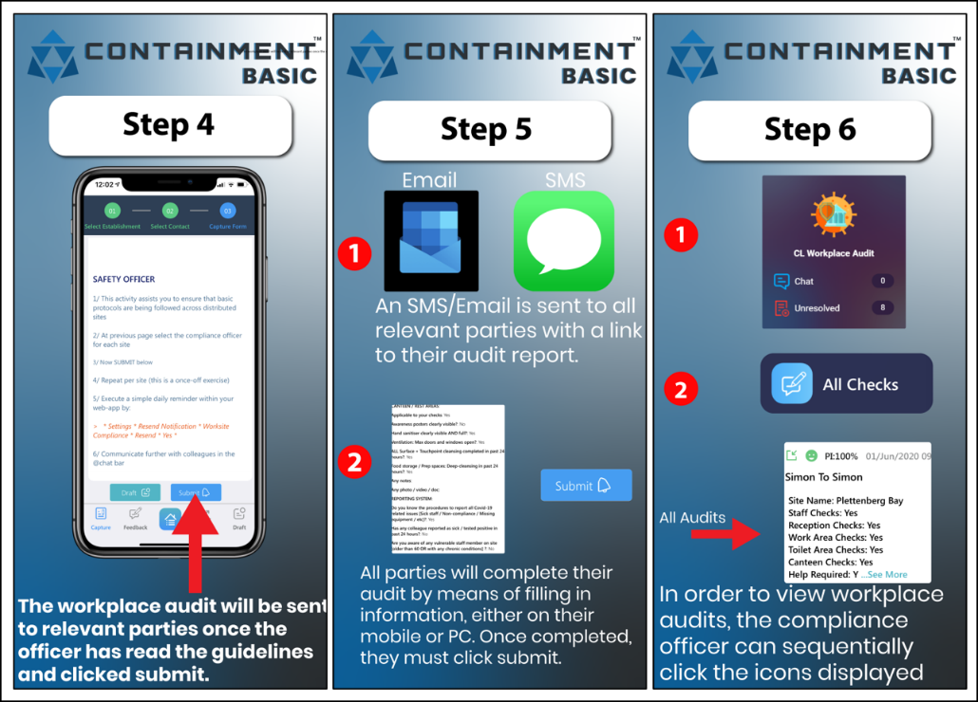
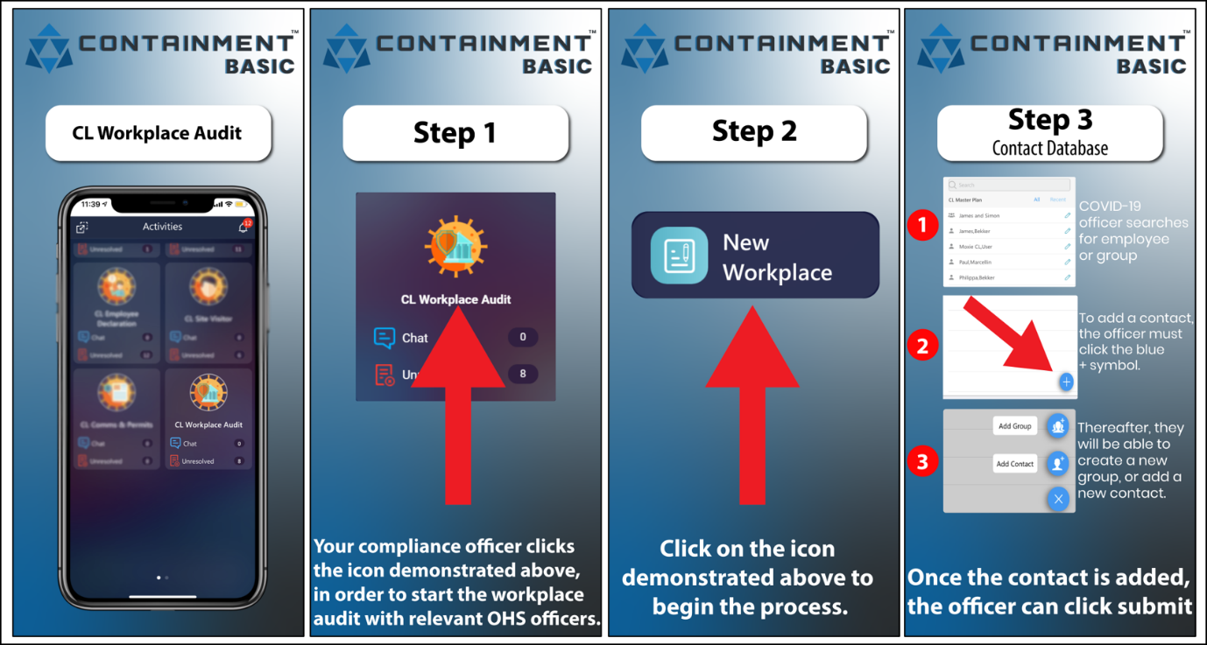
- Workplace Audit

This activity allows your organisation to run an elementary audit of each relevant workplace or site. This allows for basic regulation compliance.

The activity is controlled by your compliance officer / H&S officer.

Your compliance officer will have a login access to the Containment app / web-app, but the rest of your staff who will assist with this task have no need for an app; only a smart / feature phone with an internet connection.

The information submitted by your team will be permanently recorded referencing the specific location (username protected). This will enable your organisation to quickly understand whether a site is 100% compliant in any given cycle.

Process flow:

Part A
This part of the process is done only once per site or area
- Select activity: Workplace Audit
- Select the team member who will be assisting you on the site, OR add the employee [head+ icon]
- Select SUBMIT
- Complete the digital form and select SUBMIT
Part B
This part of the process is done per organisation time-cycle – eg per day
- Access the browser-based web app (not the mobile app)
- At top right of screen select settings [gear icon]
- From drop-list select Resend Notification
- Find Workplace Audit
- Select Resend + Yes
- The reminder is sent via SMS across all records which remain unresolved – meaning they are ‘open’. Those sites therefore remain relevant to be updated by your various team members
Notifications:
- Will be received per team member submission by all your personnel with access rights
- Notifications will be in-app
- If required, notifications can be de-activated at the Settings icon
Site records:
- The response from each team member is stored referencing their name, site name and date of submission
- Each submitted record has an indicative score, dependant on the information captured
Resolve function:
- The resolve function closes out a record, so that it is no longer highlighted for attention; but it always remains accessible
- This process is designed to have records remain non-resolved until the compliance officer no longer requires a particular site repeat audited per time cycle
  - By leaving records non-resolved enables the compliance officer to see how many work sites he/she is maintaining a rolling record of
- To resolve a record tap on the ‘tick’ icon at the records page
- It is possible to un-resolve any record by repeating this action
- The system logs the name of the user and date-stamps at every resolve / un-resolve

Context-relevant chat messages:
- Below every record there is a blue action chat bar
- To discuss an issue with a specific team member(s), all internal colleagues
- Select the chat bar
- Enter the @ sign
- From the drop list, select one or more colleagues
- Colleagues who are external to the app will have an email address and/or mobile number
- When you have selected colleague(s) type your message
- Press the + sign in order to access:
  - Attachment clip
  - Geo-location pin
  - Quick template (preloaded messages)
  - Calendar reminder
- Note:
- You can make a general note by selecting @Me as the target
- It is NOT possible to delete a chat record – be careful
- All internal colleagues (with a login access) can see all chats, whether it is @them or not
Analysis:
- Select activity: Workplace Audit
- Select button Analysis
- Select any one of the options to view summary data from various points of view
Download:
On the web app / browser interface only you have the option to download your info in a PDF or Excel / CSV format

- Select activity: Workplace Audit n
- Select button Open Records
- Click on the date-range and engage filters / dates / etc to narrow your records selection
- Select the EXCEL icon at top right
or
- Click on a specific record
- Click on the 3x dots button
- Select Export PDF

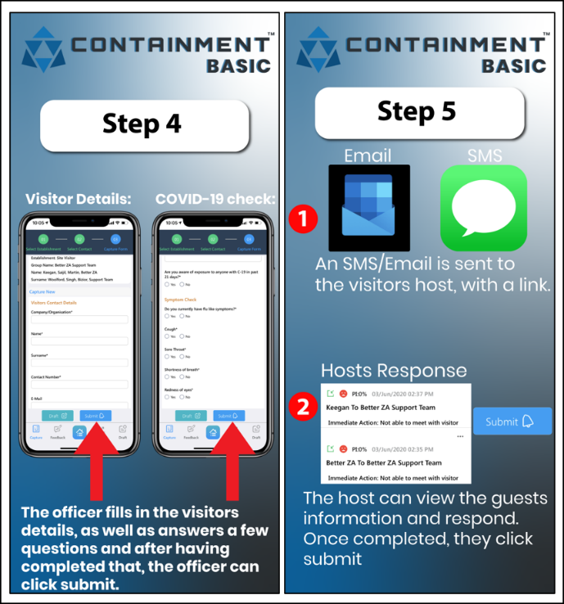
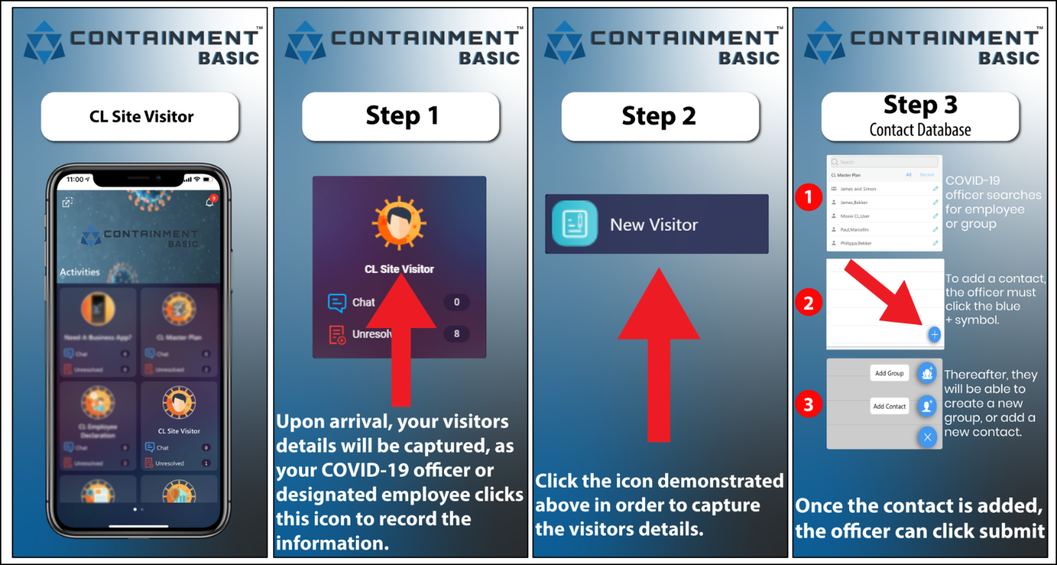
- Site Visitor

This activity allows you to screen all visitors reporting to a particular site and keep records.

The activity is controlled by an appointed receptionist, security officer or similar.

The reception officer will have a login access to the Containment app / web-app. The host who is receiving the visitor does not need an app; only a smart / feature phone or laptop, with an internet connection.

The visitor receives a score after answering a set questions. If compliant, the host is immediately notified of the visitor’s arrival. He/she is able to confirm that they are on their way to meet the visitor, or not.

The information of each site visitor is permanently recorded by company, name and person visiting.

Process flow:
- Select activity: Site Visitor
- Select New Visitor
- Select the host (staff member that is being visited), OR add the host [head+ icon]
- Complete the digital form by asking the visitor questions and select SUBMIT
- Note:
Many of the questions are mandatory
- Host receives an email and SMS notifying of visitor and whether they are cleared to enter (or not)
- Host is able to respond that they are on their way to meet visitor (or not)
- When the visit is complete, the reception officer should RESOLVE [tick icon] to close this record
- The Unresolved indicator on the Site Visitor tile will inform you how many visitors are still at your site at a given time
Notifications:
- When the host responds with intentions, a notification will be received by all your personnel with the relevant access rights
- Notifications will be in-app
- If required notifications can be de-activated at the Settings icon
Visitation records:
- Original visitor information and the response of the host is stored with company name, name of visitor and date of submission
- Each response record has an indicative score, dependant on the answers. This allows both your reception officer and your host to let the visitor know whether they may enter the site premises or not
Resolve function:
- The resolve function closes a record, so that it is no longer highlighted for attention; but it always remains accessible
- This process is designed to have records resolved when the reception officer has completed the interaction with the visitor and can see the action response from the meeting host
- To resolve a record, tap on the ‘tick’ icon on the records page
- It is possible to un-resolve any record by repeating this action
- The system logs the name of the user and date-stamps each resolve or un-resolve
Context-relevant chat messages:
- Below every record there is a blue action chat bar
- To discuss an issue with a specific team member(s), all internal colleagues
- Select the chat bar
- Enter the @ sign
- From the drop list, select one or more colleagues
- Colleagues who are external to the app will have an email address and/or mobile number
- When you have selected colleague(s) type your message
- Press the + sign in order to access:
  - Attachment clip
  - Geo-location pin
  - Quick template (preloaded messages)
  - Calendar reminder
- Note:
- You can make a general note by selecting @Me as the target
- It is NOT possible to delete a chat record – be careful
- All internal colleagues (with a login access) can see all chats, whether it is @them or not
Analysis:
- Select activity: Site Visitor
- Select Analysis
- Select any one of the options to view summary data
Download:
On the web app / browser interface only you have the option to download your info in a PDF or Excel / CSV format
- Select activity: Site Visitor
- Select All Visits
- Click on the date-range and engage filters / dates / etc to narrow your records selection
- Select the EXCEL icon at top right
or
- Click on a specific record
- Click on the 3x dots button
- Select Export PDF

FAQ’s

1/ Mandatory questions?
Q:
Some team members are reporting that they cannot submit a digital form from their device or computer
A:
Please ensure colleagues are completing all mandatory questions in a form. These are indicated by a red astrix [ * ]
The system will not allow you to submit unless all mandatory questions are answered. The system provides a prompt to show which question needs attention

2/ Number of users?
Q:
How many users may use the system?
A:
In the standard offering, we enable (1) primary user and (3) secondary user logins (authentications).
All other colleagues work with the app. There is no need to login or download any app or specific software

Q:
Why don’t people need to login or download an app?
A:
The system has been specifically designed and built to enable immediate and wide deployment. In order to achieve this, it is not practical for all users to download an app or software and login.
All users, other than those with authentication, are alerted to actions via email or / and SMS. Within these communications, there are active links which open simple browser pages for the user to interact

3/ Internet connection?
Q:
Do users need an internet connection to participate in the activities?
A:
Yes, wifi or mobile data is required to participate in the activities.
The system is very light on data use

We will be updating FAQ’s on an ongoing basis

