Corona Virus School Action Plan

Key Objectives

- Track the well-being of staff and students.

  - How are your staff feeling?
  - How are your students and their families doing?
  - What is your total school status?
  - What is the trend telling you?
  - Should staff or students come to school?

- Understand when staff, students and their families are not well and communicate with them real time using a central system.

  - Who needs urgent assistance?
  - How could they be assisted?
  - What can be done?

- Conduct school readiness and ensure health compliance is regularly maintained.

How will it work?

How does the school champion use the system?

Training will be provided

- A GoMobile reseller will train and assist a key person in your school.

- Watch the video published on the Magnitude Website: (This video will be updated as the dynamic solution is constantly enhanced)

https://www.magnitude4u.com the school system will mimic the solution that Magnitude has provided to its corporate client base.

- If you have technical or process questions with respect to how the system works, relay this to your reseller.

Using the system is simple

- The school champion will be provided access to the Magnitude APP. The Magnitude APP will be available on both a mobile phone (IOS/ANDROID) and on a (Web APP Website on your PC.
- The school champion will simply open the APP and click on a button that says Track a person.
- They will then enter the person’s name, surname, mobile number and email (if available).
- They will click submit.
- The person will be registered in the Magnitude APP.
- The parents/students will receive an SMS and or Email, daily.
- They will be asked to click on a link and reflect on their daily health status.
- Once the parents/students have provided their daily health check, the information will reflect in the schools APP.
- The school will be able to engage with further communication using their APP if required.
- The data will be automatically interpreted in the system and the relevant analytics will be created.

Please note this solution and process is constantly evolving. Please speak to your GoMobile reseller to receive updates as required.

Data Privacy

- Each school will be registered in a separate instance in the Magnitude cloud. The data will be hosted in Microsoft Azure. Why does GoMobile host your data using Microsoft Azure and specifically in South Africa?
  - This is an excerpt from business day and explains why GoMobile has chosen to host with Azure in South Africa. “According to Bezuidenhout, the launch of local Microsoft Datacentres provides Azure customers – and potential customers – with trusted Cloud services that will help them meet local compliance and policy requirements, such as the Protection of Personal Information (POPI) Act” https://businesstech.co.za/news/industry-news/303796/the-dcs-have-landed/

- Who at GoMobile could have access to your data and under what circumstances would they typically access your data?
  - GoMobile is a software development company. Its primary role is to develop a platform (CMS) that is used to create your business APP processes and to render the configured solutions into an APP that you utilize. As you utilize the APP (Web, IOS and Android) the data that is generated is uploaded and downloaded from your instance in a server provided by Microsoft.
  - In the event that you experience a technical issue (BUG) and our development team needs to access the database to understand why the BUG has occurred, then the software developers would have access to your data.
  - Our database administrators have access to the database as they are ensuring the systems are running optimally.
  - GoMobile has informed all employees that the data is private, and it is a serious offence for any party to compromise your data.
  - In no way will GoMobile authorize illegal access to your data, commercialize your data and or redistribute your data in the normal course of business. In the event that this takes place from a GoMobile perspective it would mean that the relevant party within the company had committed a serious offence.

- GoMobile contracts with resellers that provide customized solutions to the marketplace. The resellers utilize the CMS system to create and support on demand Apps for the clients that they support on behalf of GoMobile. Clearly the contract is signed between your company and GoMobile.
  - In order to understand this relationship better, think of how PowerPoint works.
    - Assume you want a presentation created for your school.
    - You decide to use Microsoft PowerPoint.
    - You sign up with Microsoft and utilize their Azure hosting services.
    - Then you utilize a 3rd party (Reseller) to create, manage and support your presentation initiatives.
    - Clearly this reseller would have access to your personal information.
    - As such if you want to protect your data it would be prudent to get the reseller to sign a specific confidentiality agreement with your company to ensure you cover yourself with respect to their access, manipulation and potential dissemination of your data.
  - In the same manner, we advise your company to sign a confidentiality agreement directly with your GoMobile reseller.
- Please note that it is exceptionally difficult to guarantee a company that their data is 100% safe in any environment. In the event that your company is concerned with the fact that GoMobile is essentially hosting your data you have the option to setup and control your own instance of the GoMobile platform. This involves the following:
  - Your own Microsoft Azure account.
  - Your own CMS system.
  - Your own inhouse CMS configurator.
  - Your own branded APP on the APP store.
    - GoMobile has clients that go to this extent and we support them accordingly. Please note that it takes 2 weeks to set this up and we do charge for the service.

- Schools will only see their data, thus protecting the schools contact list.
- The database will belong to the school at all times.
- Data relevance and manipulation with respect to POPI.
  - GoMobile is not a POPI consulting firm and we do not have intimate knowledge of POPI compliance requirements at this time.
    - We simply host your application data in some cases.
    - We have 1000’s of different processes developed on our platform that have different ramifications with respect to personal data. These applications that are added to our platform are not viewed, analyzed, manipulated by GoMobile software developers.
    - The relevance of the database is directly related to the business process that you create or request to be created by the resellers or done directly by staff in your company.
    - You have the ability to manipulate your data as you require.

Where will your data be stored and how will it be protected?

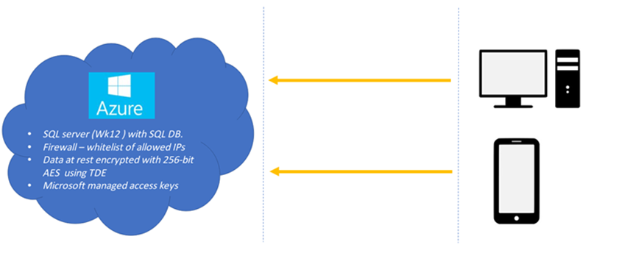
Magnitude server
TLS_ECDHE_RSA_WITH_AES_256_CBC_SHA
256-bit keys, TLS 1.2
TLS_ECDHE_RSA_WITH_AES_256_CBC_SHA
256-bit keys, TLS 1.2
Transport-level Encryption
Web API with SSL
HTTPS connection with SSL
Mobile App – Android & IOS
WWW
End Devices

Commercial Feasibility

Parties that are involved to make this project work are as follows:

- GoMobile
  - Owns the Magnitude Platform.
  - Provides the technical support for the solution to be developed via its resellers.
  - Will recreate/change and add to the solution as required within the scope of its dynamic APP creation platform.
  - Manages the existing BI dashboard and enhances as required.
  - Will configure the CMS for the school to provide their solution, where the contact database produced by the school is only visible to that school.
- Microsoft Azure
  - This is the cloud-based hosting platform that connects to the Magnitude Platform. https://azure.microsoft.com/en-us/
  - The account with Microsoft Azure is paid by GoMobile.
- Connect SMS
  - Gateway https://connect-mobile.co.za is connected to the Magnitude Platform. GoMobile has an account with Connect and pays them for each SMS sent through the system.
  - Brendan White the CEO of Connect has committed to provide SMS for this initiative at cost.
  - As each SMS is pushed through the SMS gateway, it is clear that this particular company would have access to all mobile numbers in their database. Connect systems is a reputable SMS gateway company. Please feel free to contact them if you have further data concerns in this regard. https://connect-mobile.co.za/?gclid=Cj0KCQjwwr32BRD4ARIsAAJNf_1aEX1V4sOTD3TL9KdfY0m6ZQaeadjDypvNLLHSjPUPrxx4KMkGAosaApYCEALw_wcB

We are all doing this at Cost, whilst providing our time for free.

Summary:

- We have no intention of using your private data.
- We are working at speed based on the urgency of the situation.
- In the event that you are concerned with your data protection we suggest each party that has access to the data signs a personal confidentiality agreement with your entity at this time.

